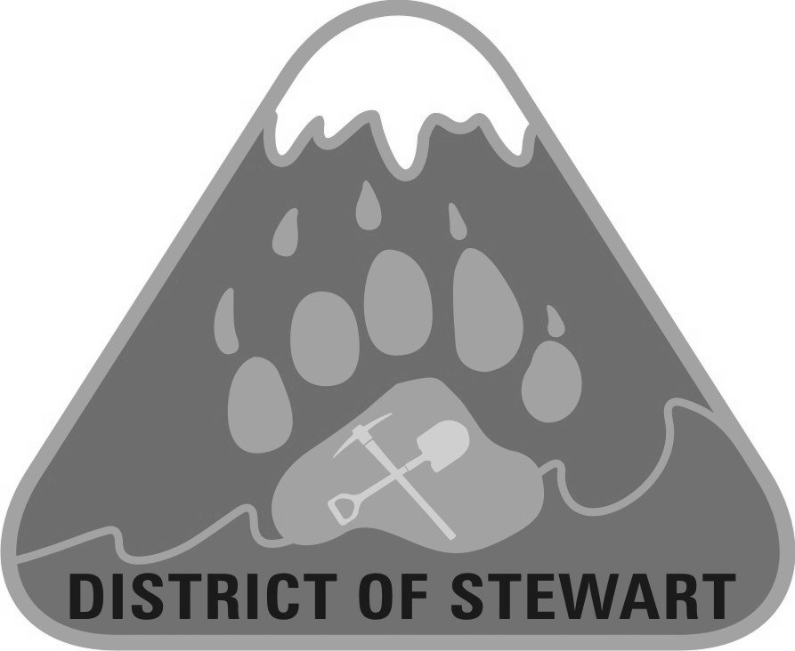

PUBLIC NOTICE

WATER QUALITY ADVISORY LIFTED

WATER SUPPLY SYSTEM COVERED BY THIS NOTICE:
Stewart Community Water System

REASON FOR THIS NOTICE:
Following an inspection of Stewart’s Community water system, effective August 27, 2024, Northern Health has LIFTED the Stewart Community Water System Water Quality Advisory.
Complaints related to discolored water in the distribution system have been minimal since the establishment of the reservoir and are now limited to times when general repair/maintenance is taking place. The Water Quality Advisory for the District of Stewart (DoS) is being removed immediately.
There is currently no evidence of risk to water users and weekly testing is being conducted to verify this. The District is working with Northern Health Authority to provide the community with the best quality of drinking water possible.

WHAT IS A WATER QUALITY ADVISORY?
A Water Quality Advisory is one of three types of public notices commonly used by a Drinking Water Officer when there may be a noticeable change in the water quality or a manageable threat to the drinking water. Water Quality Advisories are issued in situations in which the public health threat posed by the water system is modest and actions can be taken to reduce the risks through means other than requiring a Boil Water Notice or Do Not Use Water Notice.
For more information, please contact:

District of Stewart, (250) 636-2251
705 Brightwell Street, Stewart BC

